**TASK 12**

TCP Socket Programming in C

Develop a simple client-server application using TCP sockets in C:

The server listens on a specified port and accepts a client connection.

Once connected, the server sends a message "Welcome to the Server!" to the client.

The client receives the message and prints it to the console.

**CLIENT CODE**

#include <stdio.h>

#include <stdlib.h>

#include <string.h>

#include <unistd.h>

#include <netinet/in.h>

#include <sys/socket.h>

#include <arpa/inet.h>

#define PORT 8080

int main() {

    int sock = 0;

    struct sockaddr_in serv_addr;

    char buffer[1024] = {0};

    if ((sock = socket(AF_INET, SOCK_STREAM, 0)) < 0) {

        printf("Socket creation error\n");

        return -1;

    }

    serv_addr.sin_family = AF_INET;

    serv_addr.sin_port = htons(PORT);

    // Convert IP address to binary

    if (inet_pton(AF_INET, "127.0.0.1", &serv_addr.sin_addr) <= 0) {

        printf("Invalid address/ Address not supported\n");

        return -1;

    }

    // Connect to server

    if (connect(sock, (struct sockaddr *)&serv_addr, sizeof(serv_addr)) < 0) {

        printf("Connection Failed\n");

        return -1;

    }

    // Read server message

    read(sock, buffer, sizeof(buffer));

    printf("Server says: %s\n", buffer);

    close(sock);

    return 0;

}

**FILES**



**SERVER CODE**

#include <stdio.h>

#include <stdlib.h>

#include <string.h>

#include <unistd.h>

#include <netinet/in.h>

#include <sys/socket.h>

#define PORT 8080

int main() {

    int server_fd, new_socket;

    struct sockaddr_in address;

    int opt = 1;

    int addrlen = sizeof(address);

    char *message = "Welcome to the Server!";

    // Create socket file descriptor

    if ((server_fd = socket(AF_INET, SOCK_STREAM, 0)) == 0) {

        perror("socket failed");

        exit(EXIT_FAILURE);

    }

    // Attach socket to the port 8080

    setsockopt(server_fd, SOL_SOCKET, SO_REUSEADDR | SO_REUSEPORT, &opt, sizeof(opt));

    address.sin_family = AF_INET;

    address.sin_addr.s_addr = INADDR_ANY; // listen on all interfaces

    address.sin_port = htons(PORT);

    // Bind socket

    if (bind(server_fd, (struct sockaddr *)&address, sizeof(address)) < 0) {

        perror("bind failed");

        exit(EXIT_FAILURE);

    }

    // Listen

    if (listen(server_fd, 3) < 0) {

        perror("listen failed");

        exit(EXIT_FAILURE);

    }

    printf("Server is listening on port %d...\n", PORT);

    // Accept a connection

    if ((new_socket = accept(server_fd, (struct sockaddr *)&address, (socklen_t*)&addrlen)) < 0) {

        perror("accept failed");

        exit(EXIT_FAILURE);

    }

    // Send message to client

    send(new_socket, message, strlen(message), 0);

    printf("Message sent to client.\n");

    close(new_socket);

    close(server_fd);

    return 0;

}

**FILES**



**OUTPUT & SCREENSHOTS**

**01).**

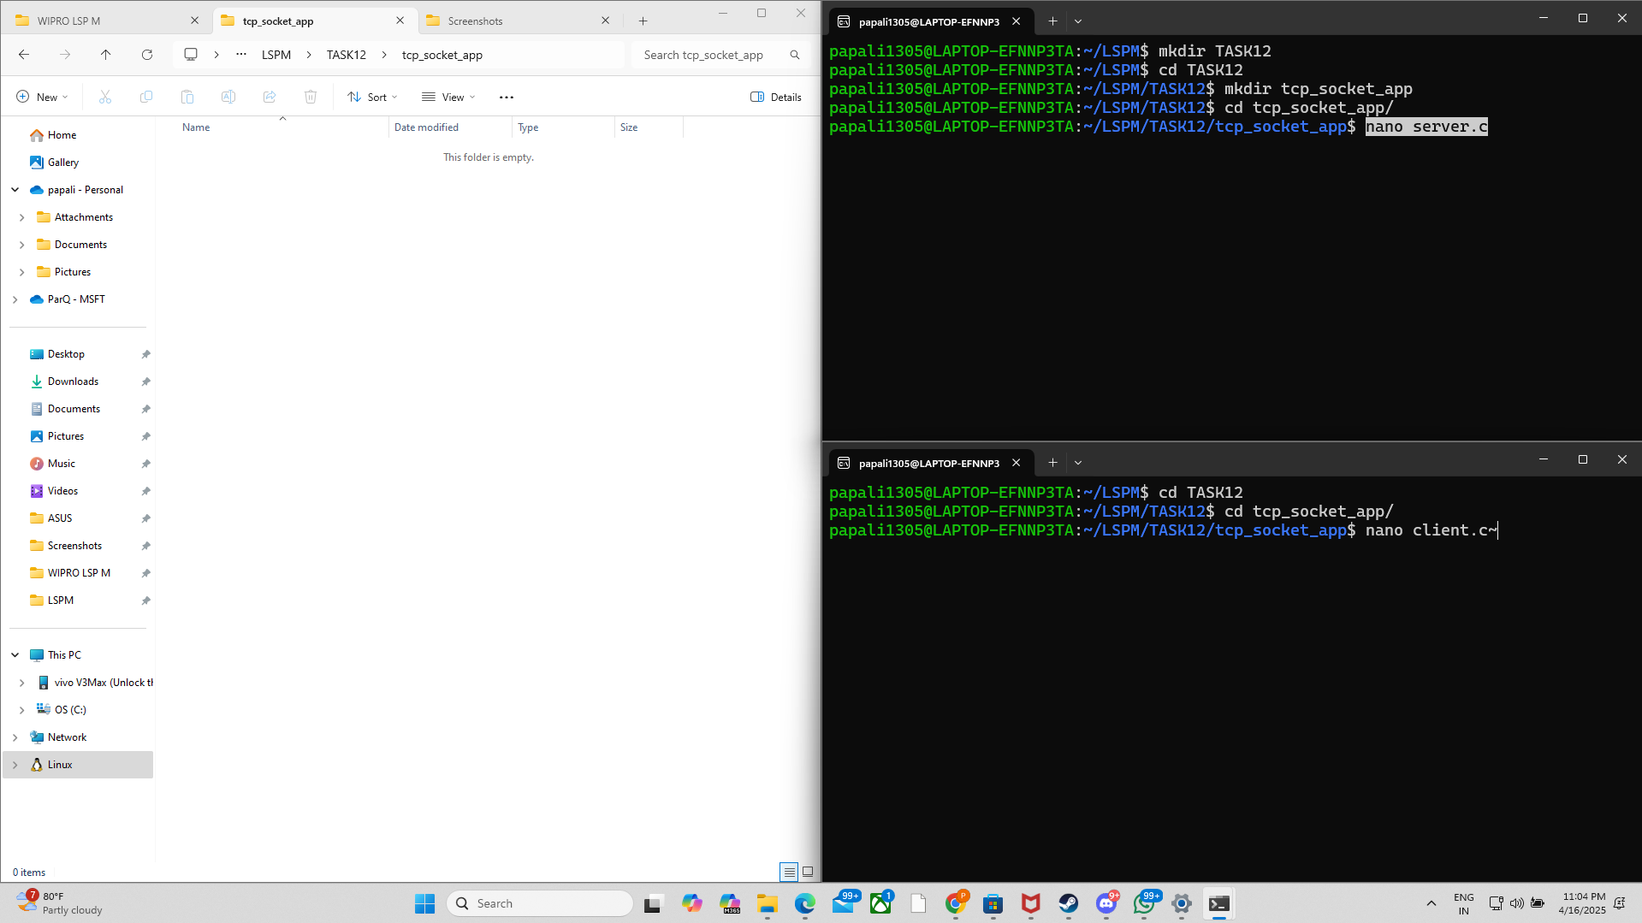

02).

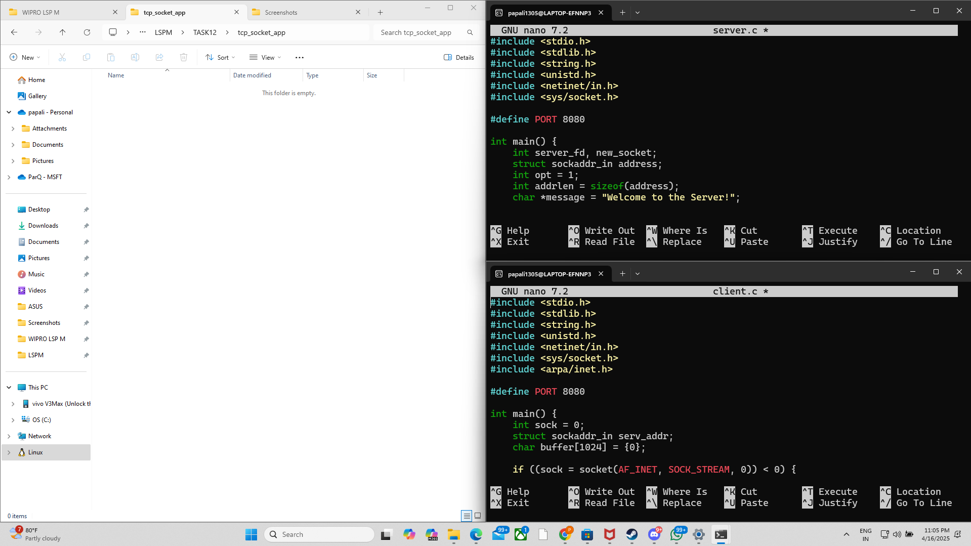

03).

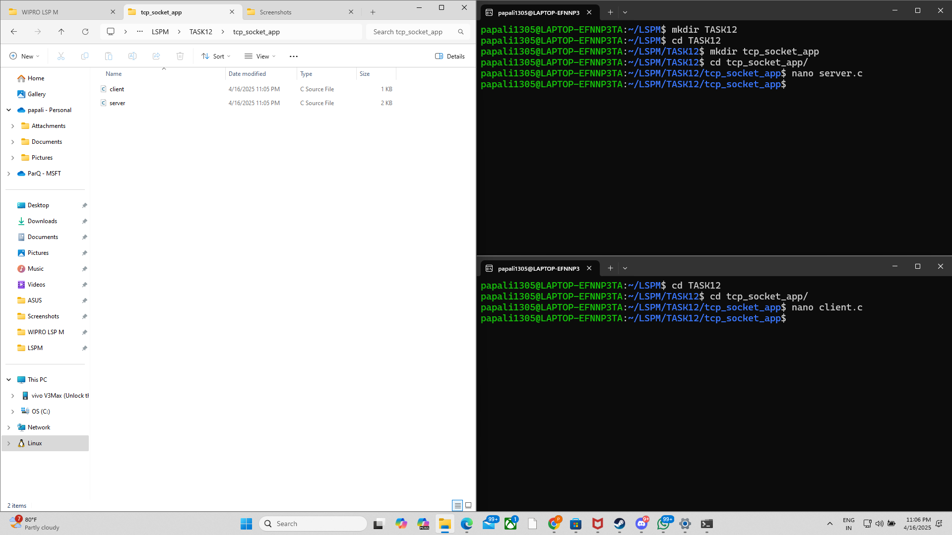

04).

